# Model description

The focus of this model is to analyze the effect of a change in the regulation of the maximum level of income insurance a person can receive after unemployment. To do so, we utilize the features of a stock-flow consistent framework and build upon the existing empirical stock flow consistent model for Denmark developed by (xyz). We contribute to the work of (xyz) by endogenizing the maximum level of income insurance. The dynamics of the model should be able to explain the macroeconomic effects of the change in the political regulations of the maximum income insurance. The next section will focus on the central equations added to include the new dynamics.

## Labor market equations

An addition to the labor market equations is the endogenization of the participation rate, with the explaining variables being the real wage, compensations rate, and unemployment rate. We include the real wage to capture the effect of a change in the incentive for people outside the labor force to start job searching (specificere hvad estimatet er I model, og sammenligne det med ADAM og andres?).   
The unemployment rate is expected to have a negative effect on the participation as a rise in the unemployment rate would shrinking the labor force and create lower participation. In addition to these the compensations rate of income insurance is included; this follows the work of (ADAM) who includes it as the only explaining factor of the participation rate. Increasing the compensation rate is expected to result in a lower participation rate, as the incentive to work would decrease with higher unemployment benefits relative to the wage.

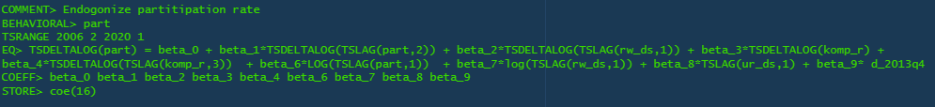

The compensation rate included in the equation for participation also appears as an endogenous variable in the model estimated as the fraction of the average amount an unemployed on income insurance would receive (dp_person), to the average wage received given employment (wage_trim).



To calculate dp_person we use a simple ols regression linking the maximum level of income insurance to the average benefits received by unemployed eligible for income insurance. This is done as an alternative of using aggregated data of benefits received by households, as the gap between observed unemployment and estimated unemployment in the model is large creating a lower average of benefits received.   
The regression is beneficial as we capture the direct effect of an increased level of maximum income insurance, (estimated er biased, da en stigning I lønnen hæver den maximale dagpenge sats, men også samtidig vil hæve det gennemsnitlige beløb modtaget af arbejdsløse på dagpenge + hæve det gennemsnitlige beløb da folk da nu komme på dagpenge og ikke ramme den makismale dagpenge sats også oplever en stigning I lønnen (dog mindre end stigningen for folk der rammer den maximale dagpenge sats) Derfor forventes estimatet at være under 1 men stadig indeholde en upwards bias grundet ovenstående forklaring.) The coefficient of the regression states that an increase in the maximum level of income insurance of 1% increases dp_person by 0.95%.

This leads to the equation for the maximum level of income insurance, as this level is only calculated once each year, the variable will only change in the 1. Quarter and stay fixed for the rest of the year. In the baseline model “max_dp” follows the political regulations stated by the ministry of Finance (<https://www.retsinformation.dk/eli/lta/2003/373>). It follows that the maximum level of income insurance grows by the state regulation percentage plus the rate adjustment percentage Each year.

As the Ministry of Finance determine the state regulation percentage it is held exogenous in the model. On the other hand, the rate adjustment percentage is calculated each year, using the adaption percentage. There are three conditions: First, if the adaption percentage is lower than 0 rate adjustment percentage is equal to the adaption percentage. Second, if the adaption percentage is between 0.0 - 0.3% the rate adjustment percentage is set to 0. Third, if the adaption percentage is above 0.3% the rate adjustment percentage is equal to the adaption percentage minus 0.3% points.   
As with “max_dp” the rate adjustment percentage is calculated in the 1. Quarter and held fixed to the end of the year.

The adaption percentage is calculated by taking the wage growth two years before the financial year subtracted by 2% point, it should be noted that it is the yearly wage growth which in the model is calculated using the 1. Quarter, therefor the adaption percentage is only calculated for 1. Quarter and held constant for the rest of the year.

The endogenization of “max_dp” is now completed within the model, and we can adjust the same variables as the Ministry of Finance when making regulations to the maximum level of income insurance. Max_dp is furthermore included in the wage equation, only having an impact on the wage in the short run.



# Validation of the model

We will in this section look at the performance of the model comparing the results from the simulation with actual data, with a specific focus on the variables in the labor market.

In the below figures we compare the simulated and actual data for GDP, Employment, maximum level of income insurance and compensation rate.

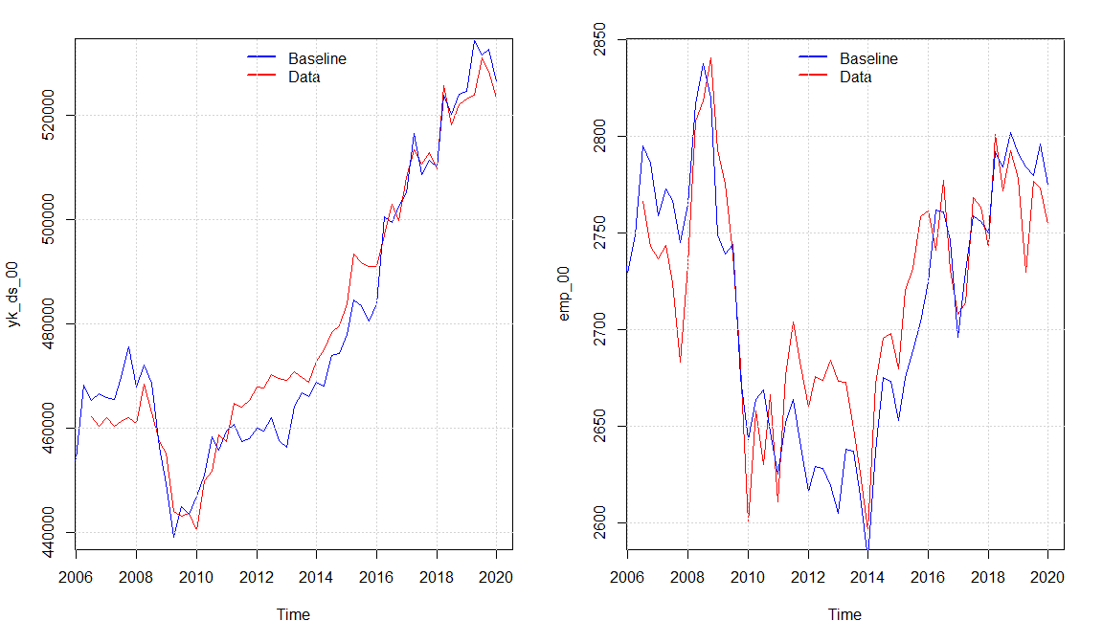

We observe that the model seems to capture the same dynamics of the real economy as (xyz) with a small overshooting in the economic activity in the period 2011 - 2016 explained by a higher simulated value of real investment and consumption compared with the data. Overall, the model seems to capture the medium to long-run tendency of the data even though there are some divergences in some quarters. The Overshooting in the activity also results in a higher level of the maximum level of income insurance in the baseline model, resulting from an increase in the wage growth. As the increase in wage growth goes directly into the compensation rate in the same period, meanwhile the maximum level of income insurance will be effected with a lag of 2 years, we observe that the compensation rate is a bit lower around 2010 - 2012, but as the adjustments happens it goes back to follow the real data.

In the next section We will look at two scenarios with different political regulations.

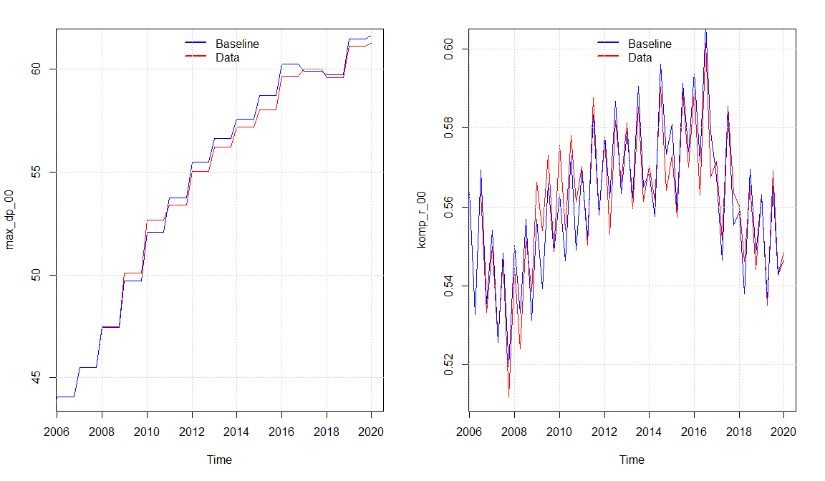

## Scenario 1 No adjustments to the statsreguleringsprocent

We now observe the case in which the Danish government would not “afdæmpe” the state regulation percentage, and thereby keeping it fixed at 2% in 2016 - 2020 where the adjustment takes place. (xyz)

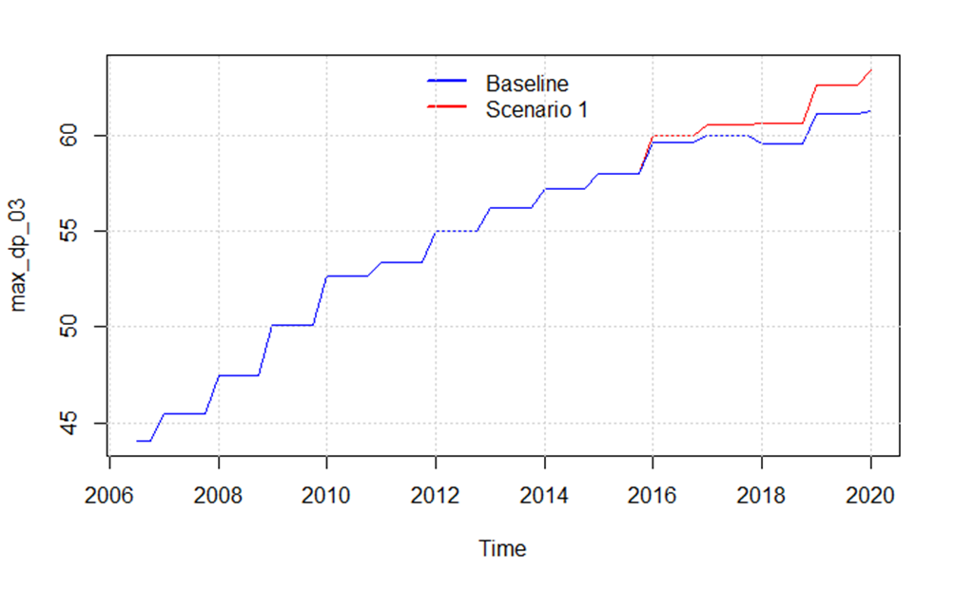

Men der er ikke den store effekt på resten af økonomien:

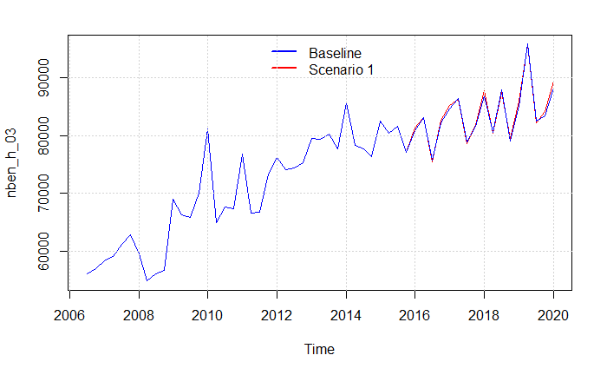

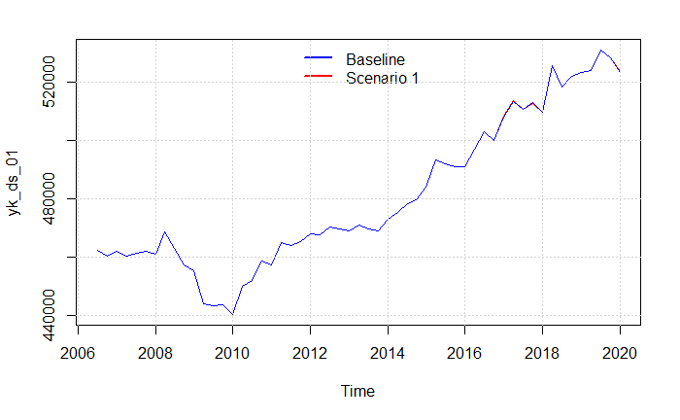

## Scenario 2 New equation for max_dp

In this scenario we change the equation for the maximum level of income insurance, so that it follows the growth in wages from the year before. First of all, this results in a much quicker adjustment of the maximum level of income insurance to changes in the wage and would be expected to increase max_dp as there will no longer be withdrawn 0.03% points when the wage increases by more than 2%.

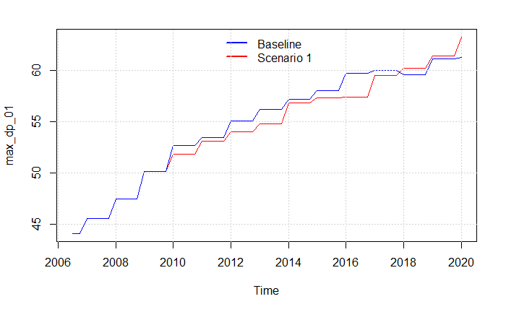

# Behavioral equations estimated

## Participation

## Wage_ds

